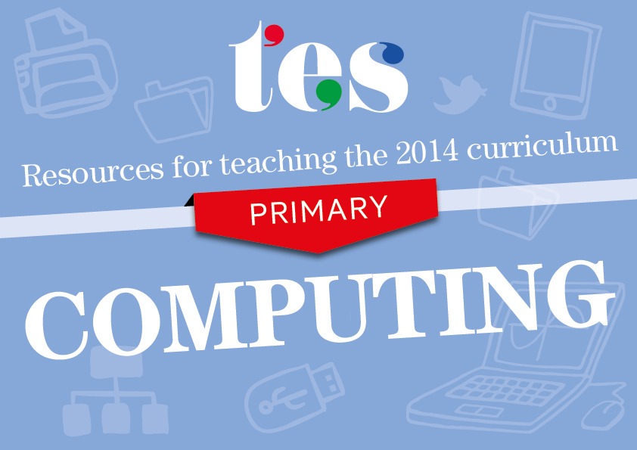Computing
Key Stages 1 and 2
Resources to help you teach the 2014 curriculum for computing

KS1 Computing
Pupils should be taught to:
- understand what algorithms are; how they are implemented as programs on digital devices; and that programs execute by following precise and unambiguous instructions | - Algorithm cards  Help pupils to learn about putting instructions into order using these cards.  - Algorithm wall chart  Create a display of algorithm definitions and examples in your classroom.  - Flow charts for instruction writing  Use these blank templates for familiarising pupils with instruction writing and algorithms.  - Direction cards  These cards help pupils to understand precise instructions before programming Roamers and Bee-Bots.
- create and debug simple programs | - Planning for floor robots  Detailed termly-planning documents for using floor robots in your classroom.  - Bee-Bot planning sheet  Instruction cards to help children to write instructions for programming Bee-Bots.  - Bee-Bot lesson plan  Pupils direct a Bee-Bot across a grid to a set destination, learning simple programming and debugging skills.  - Can you draw a rectangle?  A worksheet for pupils to write and record instructions for drawing a rectangle in Logo.
- use logical reasoning to predict the behaviour of simple programs | - Turtle planning  In this activity, pupils learn simple programming and predict how a floor robot may move to make different shapes.  - Floor turtle  Pupils programme control devices and predict their movements based on instructions.  - Moon challenge  An activity and record sheet for pupils to map, record and predict the path of a control device.  - Pro-Bot floor turtle  Detailed planning and activity documents for teaching pupils how to control a Pro-Bot floor turtle.
- use technology purposefully to create, organise, store, manipulate and retrieve digital content | - Minibeast database  Gather data to make index cards for sorting minibeasts with this TESiboard activity.  - Finding information  Termly-planning documents and activity materials for pupils to find, store and organise information.  - Yes/No diagrams  A set of worksheets for pupils to practise using branching databases.  - Virtual class data cards  Use these editable data cards for a variety of database and organisation activities.
- recognise common uses of information technology beyond school | - Robots  Introduce students to robots and machines, how they function and how they are used in society.  - How a supermarket works  A lesson plan and activity to explain to pupils how information is used in a supermarket.  - Mars Rover  This video from BBC Class Clips shows how the Mars Rover uses information technology, remote control and wireless communication.  - Computers in agriculture  Explore how computers are used to help farmers and how machines are used in agricultural processes.
- use technology safely and respectfully, keeping personal information private; identify where to go for help and support when they have concerns about content or contact on the internet or other online technologies. | - Internet safety lesson  Pupils explore the benefits and dangers of the internet, looking at how they can stay safe online.  - Online safety lesson plan  A set of detailed lesson plans and activities to outline the importance of staying safe online.  - Safer internet primary lesson plan  This lesson plan encourages pupils to identify and explore what they think a better internet might look like.  - Staying safe online  Pupils are given a number of scenarios to respond to with regards to staying safe online.

KS2 Computing
Pupils should be taught to:
- design, write and debug programs that accomplish specific goals, including controlling or simulating physical systems; solve problems by decomposing them into smaller parts | - Scratch guide  A series of 20 lessons to teach pupils the basics of Scratch programming.  - Scratch programming lesson  Video tutorials and guides for a series of Scratch lessons.  - Scratch task booklet  Use this Scratch task booklet to introduce pupils to programming.  - Scratch scheme  A six-week, introductory scheme of work with pupil and teacher guides, activities and tasks.
- use sequence, selection, and repetition in programs; work with variables and various forms of input and output | - Scratch sequence  Instructions for how to create a simple program involving traffic lights appearing and disappearing in sequence.  - Scratch programming  A scheme of work to introduce students to basic computer programming concepts through games in Scratch.  - RoboMind  Introduction to RoboMind, where pupils learn how to use the program and how to choreograph their own virtual robot dance.  - Input/output  A simple activity for pupils to consolidate learning about input and output.
- use logical reasoning to explain how some simple algorithms work and to detect and correct errors in algorithms and programs | - Algorithms  Exercises and a presentation to describe how algorithms work.  - Human crane algorithm  Pupils create and test crane algorithms that move blocks from one bowl to another.  - Jam sandwich algorithm  Use a simple programming language to write an algorithm to instruct Sandwichbot 2000 to create a sandwich.  - Sorting algorithms  This teacher guide and activities for pupils cover sorting algorithms.
- understand computer networks including the internet; how they can provide multiple services, such as the world wide web; and the opportunities they offer for communication and collaboration | - How the internet works  A short PowerPoint presentation showing how information is sent and received through the internet.  - Internet research: Fact or fiction  Discuss how the internet can be used for research and publishing information.  - Understanding the internet  Help pupils to gain an understanding of how the internet works.  - Blogging the classroom  A crib sheet for producing your own blog.
- use search technologies effectively, appreciate how results are selected and ranked, and be discerning in evaluating digital content | - Searching the internet  Activity sheet and guide for pupils to use as part of an internet search task.  - Internet research  Information and questions on the internet, parts of a URL and the benefits of internet research.  - Finding out  This lesson from Hwb Welsh Government gives instruction and advice on how to use the internet to find and evaluate information.  - Internet searching task  A set of questions on web browsing and finding information on the internet.
- select, use and combine a variety of software (including internet services) on a range of digital devices to design and create a range of programs, systems and content that accomplish given goals, including collecting, analysing, evaluating and presenting data and information | - Web design  Pupils build a live web page based on their hobbies – looking at how a page is built, and what elements are needed for a successful site.  - Movie trailers  A guide to creating movie trailers on iPads.  - Introduction to HTML  This lesson from Codecademy provides an introduction to HTML, CSS, jQuery, and Javascript.  - Introduction to databases  A set of activities and guides to introduce pupils to databases.
- use technology safely, respectfully and responsibly; recognise acceptable/unacceptable behaviour; identify a range of ways to report concerns about content and contact. | - Staying safe online  Activities and resources from Into Film to teach pupils about being safe and responsible online.  - Safer internet activities  Eight activities for lessons on internet safety.  - Using the internet safely and responsibly  A PowerPoint activity to help children understand the risks associated with different communication tools and how they can stay safe online.  - Cyberbullying lesson plan  Use this lesson plan to encourage young people to gain an understanding of cyberbullying and its consequences.

