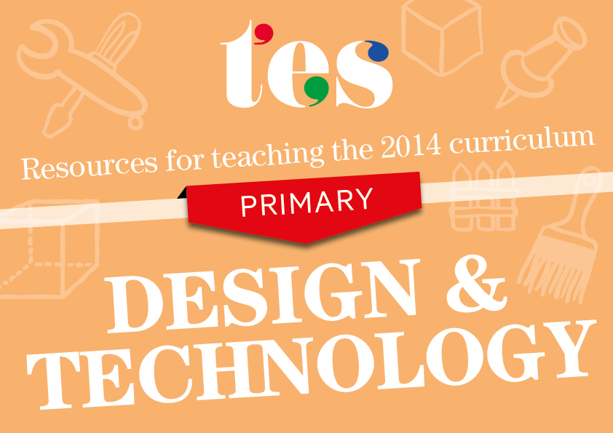
Design and technology
Key Stages 1 and 2
Resources to help you teach the 2014 curriculum for design and technology

KS1 Design and technology
When designing and making, pupils should be taught to:
Design
- design purposeful, functional, appealing products for themselves and other users based on design criteria | - Puppet making  These lesson plans on puppet making help to identify design criteria.  - Vehicles  A lesson plan and resources focussing on the design criteria of vehicles.  - Designing musical instruments  Help students to design their own musical instruments with this lesson plan, which includes associated booklets.  - Mechanism design  This resource contains a good section focussing on design criteria and mechanisms.
- generate, develop, model and communicate their ideas through talking, drawing, templates, mock-ups and, where appropriate, information and communication technology | - Using ICT in DT  A guide about how to effectively use ICT in primary design and technology.  - Modelling ideas  Help students to create moving models from drawings of mechanisms.  - Generating and developing ideas  Encourage your class to come up with and develop ideas for a rainmaker.  - Using a template  A simple lesson plan and activity about how to work from a template.

Make
- select from and use a range of tools and equipment to perform practical tasks [for example, cutting, shaping, joining and finishing] | - Knife safety  Information for students about how to use knives safely.  - Selecting tools to use  This booklet and activities will help students to learn how to pick the right tools for a job.  - Different equipment used in cookery  A range of activities and flashcards that can be used to identify tools and related safety issues.  - Making a swing, tools needed  A PowerPoint presentation about how to make a swing, with accompanying worksheets and teacher’s notes.
- select from and use a wide range of materials and components, including construction materials, textiles and ingredients, according to their characteristics | - Materials investigation  Discussing different materials and how they can be used.  - Testing materials  A worksheet and guide to testing materials to check their suitability  - Comparing materials  Students use this worksheet to describe and compare materials.  - Food suitability  A lesson plan for explaining that fruit and vegetables can be grouped, individually named and that they may require treatment before being eaten.

Evaluate
- explore and evaluate a range of existing products | - Analysing products  An activity to explore products using a thinking-hat method.  - Exploring hats  This activity looks at existing products and how to evaluate them.  - Analysing and evaluating  Help students to analyse existing products with this lesson plan.  - Product analysis  Students study a range of similar products in this analysis lesson.
- evaluate their ideas and products against design criteria | - Curriculum principles  These examples explore curriculum principles from a pupil’s perspective and consider how to meet them.  - Improving ideas  Help students to improve their ideas to ensure that they meet the design criteria.  - Evaluating designs  A lesson plan and accompanying worksheets to teach students how to evaluate design ideas.  - Making a puppet  Guide students through making a puppet and then help them to evaluate it with this complete set of resources.

Technical knowledge
- build structures, exploring how they can be made stronger, stiffer and more stable | - Strong structures  An activity to explore how to make strong structures.  - Sheet material structures  Shapes and strength/structure using sheet materials.  - Building a wooden structure  Video of constructing a wooden structure.  - Archikids  An online resource exploring architecture.
- explore and use mechanisms [for example, levers, sliders, wheels and axles], in their products | - Moving toy planning  Termly planning for making a moving toy.  - Mechanisms  Lesson plans focussing on describing and labelling mechanisms.  - Push/pull PowerPoint  A PowerPoint presentation discussing movement.  - Moving pictures  This lesson plan covers making moving pictures using slide and lever mechanisms.

KS2 Design and technology
When designing and making, pupils should be taught to:
Design
- use research and develop design criteria to inform the design of innovative, functional, appealing products that are fit for purpose, aimed at particular individuals or groups | - Developing ideas  A lesson plan with research to help students develop ideas.  - Decision aid  This resource helps pupils to make decisions about their design/product.  - Design criteria workbook  Designing a photo frame workbook, focussing on developing a design.  - Programme of study  How to interpret the new programme of study.
- generate, develop, model and communicate their ideas through discussion, annotated sketches, cross-sectional and exploded diagrams, prototypes, pattern pieces and computer-aided design | - Treasure box  Design and make a small treasure box using CAD.  - Using nets  Get your pupils to study the process of packaging, use 3D shapes from nets, develop their own ideas and design a cereal packet.  - Beast design  The design process through ideas, development and modelling.  - Designing and making  What to consider when designing and making.

Make
- select from and use a wider range of tools and equipment to perform practical tasks [for example, cutting, shaping, joining and finishing], accurately | - Puppet making  Designing and making a puppet using tools.  - Making catapults  Design and create a working model of a Roman catapult.  - Making a musical instrument  This PowerPoint presentation shows the design stages and making of a clacker.  - Design and make  Modelling ideas and how to improve making methods.
- select from and use a wider range of materials and components, including construction materials, textiles and ingredients, according to their functional properties and aesthetic qualities | - Selecting suitable materials  A lesson on how to select materials based on their function/use.  - Money containers  A project looking at suitability of material (fabric) used.  - Building a shelter  Get your pupils to explore the advantages/disadvantages of using materials.  - Comparing breads  Investigate and evaluate bread according to its characteristics.

Evaluate
- investigate and analyse a range of existing products | - Evaluation tool  A simple evaluation tool for helping pupils to analyse existing products.  - Park analysis  An engaging PowerPoint presentation and worksheet for analysing theme park ideas.  - Assessment levels  These handy assessment levels would make an excellent Assessment for Learning wall poster, or a reference sheet to put in exercise books.  - Lights investigation  This pupil booklet leads students through the design process, starting with initial investigation.
- evaluate their ideas and products against their own design criteria and consider the views of others to improve their work | - Self/peer assessment  A set of versatile peer-/self-assessment level sheets and a PowerPoint presentation to go with it.  - Peer assessment  This peer-assessment task will help students to highlight areas to improve.  - Practical evaluation and success criteria  These evaluation PowerPoint presentations include demonstrations and success criteria.  - Evaluation sheet  A simple sheet that encourages children to evaluate their work.
- understand how key events and individuals in design and technology have helped shape the world | - Present and future technology  A lesson in which pupils discuss present and future technologies.  - Dyson design process  These videos on the design process and becoming an engineer focus on the Dyson brand.  - Visual arts  Pupils create a visual arts dictionary and research famous artists/designers in this engaging lesson.  - Famous inventors  This PowerPoint presentation will introduce students to some famous inventors.

Technical knowledge
- apply their understanding of how to strengthen, stiffen and reinforce more complex structures | - Shelters  A lesson to consider how structures can fail and to explore ideas of how to strengthen them.  - Bridges  This resource pack looks at bridge types and how to increase their strength.  - Structures workbook  A workbook that takes a look at more complex structures and how they are strengthened  - Structure tests  These tasks will help children to test the strength and suitability of materials.
- understand and use mechanical systems in their products [for example, gears, pulleys, cams, levers and linkages] | - Video on gears  A short video to explain how gears work.  - Gears and mechanisms  These web pages look through at gears and mechanisms in detail.  - Fairground pulleys  A workbook and connected PowerPoint presentation for looking at fairground rides and how they work.  - Moving toys workbook  Help students to explore cams and moving toys with this workbook.
- understand and use electrical systems in their products [for example, series circuits incorporating switches, bulbs, buzzers and motors] | - Electronic chooser chart  Fill in the blanks chart to help pupils’ understanding of electronic components.  - Introduction to electronics  This lesson plan and guide provide a good introduction to electronics.  - Buggy circuit  Students can design and make a controllable buggy with the help of these resources.  - Electronic billboard  A unit for creating an electronic billboard.
- apply their understanding of computing to program, monitor and control their products. | - Lighting it up – Ideas  A whole term of lesson plans on how lights can be controlled.  - Building circuits  This unit on building circuits teaches students to use a computer to control their products.  - Control and modelling  A set of lesson plans and activities about using control.  - Sensors  An engaging starter activity that introduces pupils to sensors and their applications in today's world.

KS1 Cooking and nutrition
Pupils should be taught to:
- use the basic principles of a healthy and varied diet to prepare dishes | - Investigating food  This workbook will help students to understand food and healthy eating.  - Healthy eating activity  Worksheets that explore how to eat a healthy diet.  - Preparing fruit and veg  These planning and resources materials cover the preparation of different foods.  - Planning to cook  A selection of primary cooking resources from the British Nutrition Foundation.
- understand where food comes from | - Food comes from plants or animals  These plans and resources look at how all food is from plant or animal origin.  - Wheat to seed  Help students to explore where bread comes from and the processes it undergoes.  - Different ingredients for cooking  A set of resources looking at different ingredients.  - Where does our food come from  A resource for sorting food depending on its origin.

KS2 Cooking and nutrition
Pupils should be taught to:
- understand and apply the principles of a healthy and varied diet | - Balanced diet  A set of plans and resources on a balanced diet.  - Healthy eating  This activity on food groups and nutrition with help students to eat more healthily.  - The Eat Well plate  Introduce students to the Eat Well plate to get a good balance in your diet.  - Teachers guide to healthy eating  These resources will act as a guide to teaching about healthy eating.
- prepare and cook a variety of predominantly savoury dishes using a range of cooking techniques | - Food skills  A range of resources on various food-preparation skills.  - Bread recipe cards  Step-by-step recipe cards for making bread.  - Fishcakes  A simple recipe for making fishcakes.  - Eggs factor  This resource lists different ways that eggs can be used in cooking.

- understand seasonality, and know where and how a variety of ingredients are grown, reared, caught and processed | - Farm to fork  Planning documents, worksheets and activities to explain to pupils how food is grown and processed.  - Why farming matters  These activities explore the role of farming in food production.  - Food and farming  A range of resources on how food can be processed.  - Food is farmed or grown  Resources to teach about how food is farmed or grown.

