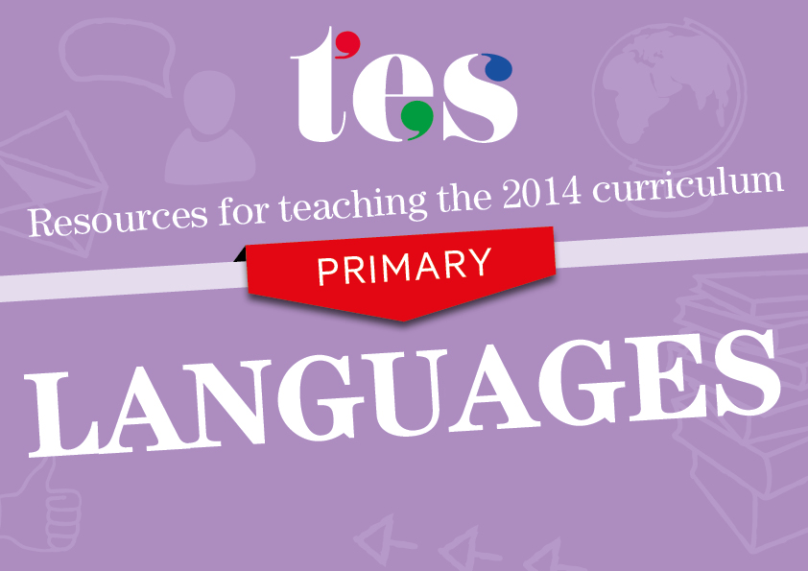
French
Key Stage 2
Resources to help you teach the following 2014 curriculum areas for French:

- Listening
- Speaking
- Reading
- Writing

KS2 French - Listening
Pupils should be taught to:
Listening
- listen attentively to spoken language and show understanding by joining in and responding | - Introductory unit of work  This set of resources and lesson plans covers introductory language, greetings and interactions.  - Guessing games  Develop listening skills while revising key vocabulary and practising questioning using this guessing activity.  - Food shopping in France  Children must listen and learn from each other to discover new food vocabulary in this lesson on shopping.  - Body parts bingo  An engaging listening activity where pupils mark bingo cards as they hear different body-related vocabulary.
- explore the patterns and sounds of language through songs and rhymes and link the spelling, sound and meaning of words | - Teaching language through music  Engage pupils in music and memory activities to learn sounds, rhyming words and correct pronunciation.  - Introductory week resources  Focus on the sound “oi” in your first week of teaching French in September using this presentation and accompanying worksheets.  - Sound dictionary  Pupils collect and sort new words by sound rather than by topic in this vocab booklet that reinforces letter-sound links.  - Song to learn avoir  Help children to remember the conjugation pattern for avoir using a song set to a familiar tune.

KS2 French - Speaking
Pupils should be taught to:
Speaking
- engage in conversations; ask and answer questions; express opinions and respond to those of others; seek clarification and help | - These shoes are made for talking  Use this drama-based resource to encourage spontaneous speaking skills amongst your students.  - Speaking line activity  Encourage speaking confidence with this activity in which students exchange information about themselves.  - Find someone who  Sports and students’ opinions are the topic of conversation with this questioning task.  - Encouraging pupils to use French in lessons  Employ this reward scheme to recognise use of the target language in class.
- speak in sentences, using familiar vocabulary, phrases and basic language structures | - Dice speaking activity  Students roll the dice to adapt sentences with familiar vocabulary in this easily-differentiated activity.  - Key structures – building sentences  Build on prior knowledge with this PowerPoint presentation that embeds sentence building with infinitives.  - Classroom objects pair work  Boost your students’ speaking skills with this pair-work activity where they record what classroom equipment their peers have.  - All about me  A series of lessons to challenge pupils to use more complex language to describe themselves.
- develop accurate pronunciation and intonation so that others understand when they are reading aloud or using familiar words and phrases | - Phonics-to-phrases reading scheme  Introduce grapheme-phoneme correspondences with these fun character cards and activities.  - Key phonics sounds  Practise common phonics using this colourful slide that can be printed to stick in books.  - French phonics work  This comprehensive resource pack contains different activities, presentations and worksheets on phonics.  - Introduction to sports  This presentation includes sound bites to reinforce pronunciation of different sports and pastimes.
- present ideas and information orally to a range of audiences | - Weather lesson  This lesson supports pupils in preparing their own weather forecast to present to the class.  - Monster lesson plan  Children design their own monster and explain its characteristics to their partner.  - From talk to performance  A creative scheme of work that uses French stories to lead up to pupils performing their own piece.  - Le serveur bizarre  An engaging lesson plan and PowerPoint presentation that focuses on a role play with a twist.

KS2 French - Reading
Pupils should be taught to:
Reading
- read carefully and show understanding of words, phrases and simple writing | - Time match-up cards  This activity requires students to match up the time in numerical form with the written words.  - Self and personal identity comprehension  Develop your students’ reading skills with this comprehension and gap-fill activity.  - Postcards  Apply comprehension strategies in this activity based on three holiday postcards.  - Dans une rue française  A visually-supported text that describes a street in France and asks follow-up questions in French.
- appreciate stories, songs, poems and rhymes in the language | - A drama toolkit for language teaching  Inspire pupils using traditional French stories from the Caribbean as part of this project pack with resources.  - Ma surprise du zoo  A charming animal-themed story with supporting activities, flashcards and games.  - Cinderella  Emphasise language points while also engaging children with a familiar fairy tale told in French.  - Savez-vous planter les choux?  A French song with actions to help pupils learn different body parts and the option to create their own verse.
- broaden their vocabulary and develop their ability to understand new words that are introduced into familiar written material, including through using a dictionary | - Histoires sans paroles  Pupils practise using dictionaries, verb tables and phrase toolkits as part of this unit on picture books.  - Dictionary skills  Explain how a dictionary works and demystify verb tables to support children in using these tools independently.  - Harry Potter  Explore new vocabulary using reading strategies with this lesson on J.K. Rowling’s famous wizard.  - Family: reading and writing skills  Pupils write their own description based on what they can elicit from this introduction to The Simpsons.

KS2 French - Writing
Pupils should be taught to:
Writing
- write phrases from memory, and adapt these to create new sentences, to express ideas clearly | - Time and daily routine  An assessment on pupils’ knowledge of describing their daily routine with pointers in English.  - Vocabulary booklets  Pupils learn, reinforce and memorise key words and phrases using these topic booklets.  - School subjects sentence building  A kinaesthetic whole-class activity that develops pupils’ awareness of how to adapt and develop sentences.  - Points system to improve writing  This reward scheme motivates children to improve their writing by adapting and re-using familiar structures.
- describe people, places, things and actions orally and in writing | - Exploring literacy through Storybird  Guidance and ideas on how to use online tools to promote descriptive writing in French.  - Places in town  A PowerPoint presentation to introduce how to describe the facilities and main buildings that are in a town.  - Lesson on clothes  This lesson works up from word to sentence level using speaking and reading skills, culminating in a writing task.  - Writing poetry  Acquaint your class with calligrams and let them to be creative in writing their own poems with these templates.
- understand basic grammar appropriate to the language being studied, including (where relevant): feminine, masculine and neuter forms and the conjugation of high-frequency verbs; key features and patterns of the language; how to apply these, for instance, to build sentences; and how these differ from or are similar to English. | - Language learning skills  This resource pack contains a variety of activities to promote awareness of cognates, false friends and basic language skills.  - Introduction to “er” verbs  Tackle the conjugation of regular “er” verbs in the present tense with this PowerPoint presentation.  - Pyramid sentence building  Cultivate learners’ abilities to extend sentences with this framework that has a competitive element.  - Rainforest animals: adjectives  Concentrate on gender agreement of adjectives in this colourful presentation about tropical animals.

