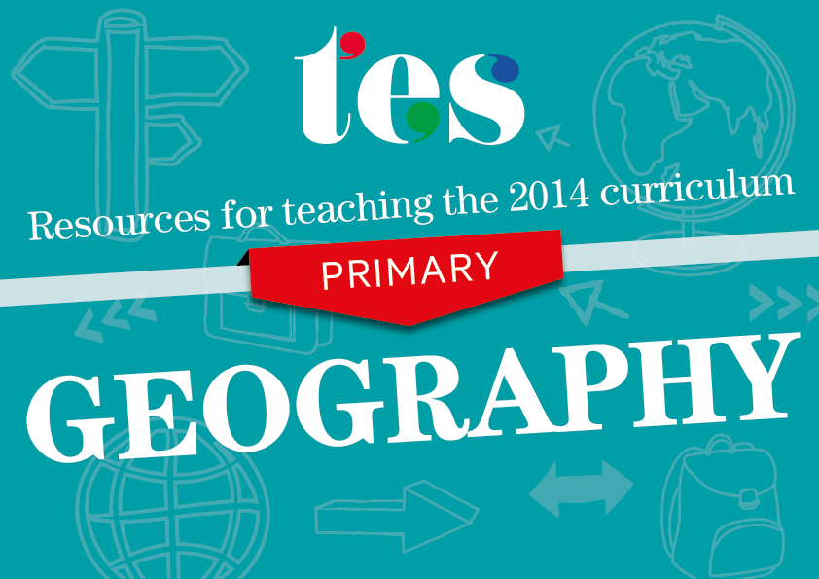
Geography
Key Stages 1 and 2
Resources to help you teach the 2014 curriculum for Geography

KS1 Geography
Pupils should be taught to:
Locational knowledge
- name and locate the world’s seven continents and five oceans | - Blank world map  An exercise in which pupils use an atlas to name the world’s continents and oceans.  - World jigsaw  A differentiated resource in which pupils assemble mixed-up pictures to create a world map.  - Commonwealth dominoes  In this activity, pupils find out facts about different continents in order to eventually play a game.  - Label the world’s oceans  A worksheet activity, with key words, about locating the oceans of the world.
- name, locate and identify characteristics of the four countries and capital cities of the United Kingdom and its surrounding seas | - The United Kingdom  An overview of the countries of the UK and distances between some of  the cities.  - Locating the UK lesson  A fully-resourced lesson that looks at the different countries of the UK and their location on a map.  - London landmark fact sheets  A series of fact sheets on key London locations with text and pictures.  - UK and Ireland PowerPoint presentation  A presentation that includes facts about and pictures of the major cities in the UK and Republic of Ireland.

Place knowledge
- understand geographical similarities and differences through studying the human and physical geography of a small area of the United Kingdom, and of a small area in a contrasting non-European country | - Day in the life - Zimbabwe  A lesson in which pupils are able to discuss the similarities and differences between life for a school child in Africa and in the UK.  - Asha’s village  Use this story of a girl in an Indian village to compare features of the UK and India.  - Types of houses  A collection of houses from the UK and around the world to stimulate discussion.  - Is it Africa or England?  A presentation showing images from the UK and various countries in Africa.

Human and physical geography
- identify seasonal and daily weather patterns in the United Kingdom and the location of hot and cold areas of the world in relation to the Equator and the North and South Poles | - Interactive weather chart  An adaptable presentation to help identify key features of the UK weather.  - Weather station role play  An activity in which pupils present a fictional UK weather forecast.  - Weather word wall  A selection of key words to either stick on the wall or use during a lesson to recap weather.  - Around the world  A presentation that gets pupils talking about places around the globe in terms of climate and location.
- use basic geographical vocabulary to refer to:  - key physical features, including: beach, cliff, coast, forest, hill, mountain, sea, ocean, river, soil, valley, vegetation, season and weather  - key human features, including: city, town, village, factory, farm, house, office, port, harbour and shop | - Geographical technical vocabulary  A list of key words that satisfies the new curriculum programmes of study.  - Geographical features  A worksheet that gets students to label pictures with geographical words.  - Jigsaw of coastal features  A collection of jigsaws of key coastal features.  - Physical or human sheets  Pupils identify human or physical features using key words.

Geography skills and fieldwork
- use world maps, atlases and globes to identify the United Kingdom and its countries, as well as the countries, continents and oceans studied at this key stage | - UK map and grid references  A lesson that introduces students to basic grid references using the UK as a case study.  - Grid reference game  A collection of pictures that will help pupils to learn basic grid references.  - James and the Giant Peach map journey  Pupils use atlases to identify the different countries the peach visits in Roald Dahl’s book.  - UK map activity  A map task that gets students using an atlas to identify key features of the UK.
- use simple compass directions (North, South, East and West) and locational and directional language [for example, near and far; left and right], to describe the location of features and routes on a map | - Zoo map lesson  A grid activity that can be differentiated to include compass directions.  - Treasure map  Two blank treasure maps with compass points to allow students to create their own trails.  - Treasure hunt  A series of worksheets to help pupils grasp compass points.  - London underground exercises  An imaginative way to teach students about direction and using maps.
- use aerial photographs and plan perspectives to recognise landmarks and basic human and physical features; devise a simple map; and use and construct basic symbols in a key | - Make a map lesson  A lesson that incorporates atlases and ICT to get students to create  their own maps.  - Map symbols PowerPoint presentation  A simple presentation that introduces pupils to map symbols.  - Making a map of the classroom  A detailed presentation and activity with aerial photographs that will help pupils to construct a map of their own.  - Miss Ward creates a map and key  An easy-to-use worksheet to help pupils create a map and key.
- use simple fieldwork and observational skills to study the geography of their school and its grounds and the key human and physical features of its surrounding environment. | - Maps  A lesson in which pupils study the features of a school and design their own map.  - Elf hunt  Students navigate around their school grounds to find hidden pictures of elves.  - Scavenger hunt  A simple and adaptable worksheet for pupils to use when observing features in their school grounds.  - Letter to our school  A Digimap lesson guide for teachers about locating their school.

KS2 Geography
Pupils should be taught about:
Locational knowledge
- locate the world’s countries, using maps to focus on Europe (including the location of Russia) and North and South America, concentrating on their environmental regions, key physical and human characteristics, countries, and major cities | - Continents, countries and capitals  A variety of worksheets, workbooks and activities to help teach students about continents.  - Lonely Planet Not-For-Parents  Over 50 pages of activities and lesson plans to teach students about countries and continents of the world.  - KS2 maps pack  A pack that contains maps of the UK, Europe and the world in various formats.  - Russia PowerPoint presentation  This presentation on Russia uses maps and pictures as a focus.
- name and locate counties and cities of the United Kingdom, geographical regions and their identifying human and physical characteristics, key topographical features (including hills, mountains, coasts and rivers), and land-use patterns; and understand how some of these aspects have changed over time | - Britain’s landscapes: Human and physical  A fully-resourced lesson that will help pupils to identify key human and  physical aspects of the UK.  - Village settlers  Pupils use atlases to identify settlements in the UK through their historic place names.  - Mount Snowdon  A detailed presentation on the key features of Mount Snowdon.  - How we use the River Thames  A detailed lesson that explains the location of the river, its route and uses.
- identify the position and significance of latitude, longitude, Equator, Northern Hemisphere, Southern Hemisphere, the Tropics of Cancer and Capricorn, Arctic and Antarctic Circle, the Prime/Greenwich Meridian and time zones (including day and night) | - Latitude to longitude  A lesson that introduces pupils to key features of a world map.  - Latitude and longitude Battleships  This activity based on the game Battleships would suit gifted and talented students.  - Locating volcanoes using longitude and latitude  A colourful activity that can be completed in 3D or on an A4 sheet of paper.  - Lines of latitude and longitude  A worksheet in which pupils use navigation to locate continents and other positions around the globe.

Place knowledge
- understand geographical similarities and differences through the study of human and physical geography of a region of the United Kingdom, a region in a European country, and a region within North or South America | - Italy worksheet  A set of differentiated worksheets that focus on key human and physical features of Italy.  - Country fact file  A worksheet in which pupils use the internet to research key human and physical aspects of a country.  - Weather and climate around the world  This lesson looks at different weather systems around the globe, including those of the UK and Brazil.  - Rainforest story cards  A multi-layered activity in which pupils can study what life is like for people in the rainforest.

Human and physical geography
- Describe and understand key aspects of physical geography, including:  - climate zones, biomes and vegetation belts, rivers, mountains, volcanoes and earthquakes, and the water cycle | - Water cycle file  A large set of resources that could be used in lessons or for  homework.  - Human or physical?  An activity in which pupils study images of their local area and sort them into human or physical features.  - Volcanoes  A presentation that goes through the main features of volcanoes from around the world.  - Mountain ranges around the world  An information sheet that summarises the different mountain ranges on each content.
- Describe and understand key aspects of human geography, including:  - types of settlement and land use, economic activity including trade links, and the distribution of natural resources including energy, food, minerals and water | - Food and nutrition infographic  A single-page visual resource that encourages students to discuss the distribution of food and money in Africa compared to the UK.  - Fair trade introduction  A PowerPoint presentation that explains the process of fair trade.  - Access to clean water  A presentation that gets pupils thinking about the consumption of water around the world.  - Making a world of difference  A full lesson that explores how fair trade is conducted using case studies.

Geography skills and fieldwork
- use maps, atlases, globes and digital/computer mapping to locate countries and describe features studied | - Geography quiz – using atlases  A series of differentiated quizzes for use in lessons.  - Locating rainforests on a world map  An internet lesson that will help students to use a map to locate the world’s major rainforests.  - Antarctica map atlas  A set of activities that focuses on studying maps and atlases to find key locations in Antarctica.  - Longest rivers in the world  An activity in which pupils use atlases and online maps to identify the locations of 15 major world rivers.
- use the eight points of a compass, four and six-figure grid references, symbols and key (including the use of Ordnance Survey maps) to build their knowledge of the United Kingdom and the wider world | - Maps and symbols pairs game  A revision and recap exercise covering the main symbols found on ordinance survey maps.  - Grid referencing and map skills  This resource includes activities in which pupils gain experience of using grid references and maps.  - Introducing grid references  A presentation that introduces students to four-figure grid references.  - Elements of a map  A simple test that includes questions about compass points, symbols and grid references.
- use fieldwork to observe, measure, record and present the human and physical features in the local area using a range of methods, including sketch maps, plans and graphs, and digital technologies. | - KS2 – Explore your area  A fully-resourced set of activities to equip students with everything they  need to investigate their local area.  - Mission: Explore your community  A complete unit of activity ideas for getting young people involved in their local area.  - Resources based on the River Thames  A selection of maps and information sheets to help support a local study unit.  - Inference grid – Isle of Wight  This resource, which introduces pupils to observation and inference, can be adapted for any area.

