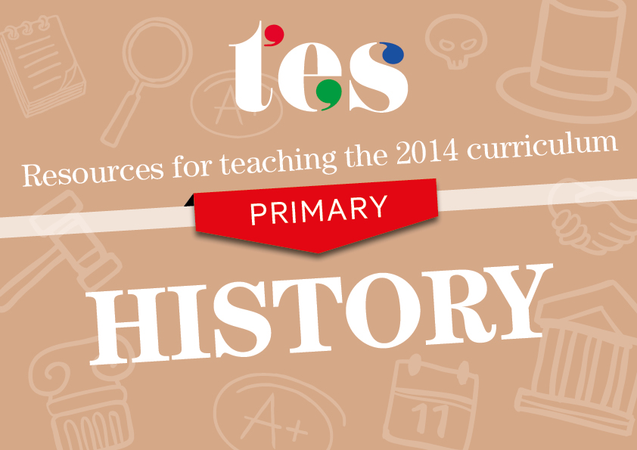
History
Key Stages 1 and 2
Resources to help you teach the 2014 curriculum for history

KS1 History
Pupils should be taught about:
- changes within living memory. Where appropriate, these should be used to reveal aspects of change in national life | - Change in me  A scheme of work aimed at developing children’s history skills while thinking about changes within their lives.  - Houses and homes long ago  An imaginary story that gets pupils thinking about how home life in the past compares to their own.  - Old and new toys  A cut-and-stick exercise in which pupils identify old toys and those from current times.  - Seaside holidays  These images of old and new scenes from the seaside will help promote discussion in class.
- events beyond living memory that are significant nationally or globally [for example, the Great Fire of London, the first aeroplane flight or events commemorated through festivals or anniversaries] | Great Fire of London  - The Great Fire of London  A set of worksheets exploring the main events and consequences of the Great Fire of London.  - SEN Great Fire of London  A set of flashcards to help pupils to sequence the main events of the fire.  - Samuel Pepys diary  A presentation that covers the main events of the day of the fire.  - Great Fire of London planning  A scheme of work and resources to help plan a sequence of lessons.  Gunpowder Plot  - Bonfire Night  A PowerPoint presentation that tells the story of Guy Fawkes and also has links to quizzes about the event.  - The Gunpowder Plot PowerPoint  A presentation that tells the story of the Gunpowder Plot and also includes pictures and poems.  - Remember, remember the fifth of November  These two posters outline the key events of the plot and other facts.  - Gunpowder Plot quiz  A presentation that includes questions about the event.
- the lives of significant individuals in the past who have contributed to national and international achievements. Some should be used to compare aspects of life in different periods [for example, Elizabeth I and Queen Victoria, Christopher Columbus and Neil Armstrong, William Caxton and Tim Berners-Lee, Pieter Bruegel the Elder and LS Lowry, Rosa Parks and Emily Davison, Mary Seacole and/or Florence Nightingale and Edith Cavell] | Queen Victoria  - The Victorians  A PowerPoint presentation about the Victorians that includes display material about Queen Victoria.  - The Victorians  A presentation that focuses on all aspects of the period with special attention paid to the monarch.  - Images of Queen Victoria  A selection of images spanning the Queen’s life.  - Queen Victoria and the Industrial Revolution  A fully-resourced lesson with a focus on recalling key facts about Queen Victoria.  Florence Nightingale  - Florence Nightingale  A selection of cards and worksheets to help you deliver an enquiry into Florence Nightingale.  - Florence Nightingale – Comparison lesson  A PowerPoint presentation that compares the work of modern nurses to those of Florence Nightingale’s era.  - Life events of Florence Nightingale  An activity that asks students to place key events of Nightingale’s life in the correct chronological order.  - Florence Nightingale presentation  A detailed summary of Nightingale’s life and work.  Christopher Columbus  - Christopher Columbus  A presentation with comprehension questions about Columbus’ life.  - Christopher Columbus and Neil Armstrong  A lesson plan and resources about these two explorers.  - Christopher Columbus activities  This data-capture sheet will help students to build a picture of Columbus and his voyages.  - Columbus word bank  A colourful key word bank with pictures.  Other  - The Life of Captain Cook  A PowerPoint presentation and resources about the life and times of Captain Cook.  - The Race for Space – Neil Armstrong  A fully-planned and resourced series of lessons on Neil Armstrong and the moon landings.  - Grace Darling resource pack  A resource pack with lesson plans to help deliver a sequence of lessons.  - Story of Thomas Becket  A detailed presentation covering the main events of Thomas Becket’s life.
- Significant historical events, people and places in their own locality. | - Mary Queen of Scots  A sequence of lessons about Mary Queen of Scots that helps to build a story about the key events in her life.  - Farming history  A collection of farming pictures and a worksheet to help build a local study about agricultural changes.  - Cornish tin mining lesson  A local study into mining with worksheets and links to help with setting up an enquiry.  - Local history testaments  This video from Teachers TV gives an example of how to incorporate local history into your lessons.
KS2 History
Pupils should be taught about:
changes in Britain from the Stone Age to the Iron Age
Examples (non-statutory)  This could include:  - late Neolithic hunter-gatherers and early farmers, for example, Skara Brae  - Bronze Age religion, technology and travel, for example, Stonehenge  - Iron Age hill forts: tribal kingdoms, farming, art and culture | - Neolithic Britain  A bank of images that could be used to introduce the Neolithic period or promote deeper questioning of the time.  - Skara Brae teacher's guide  Background information to the area and its history.  - Step into the Stone Age A detailed PowerPoint with links to introduce the Stone Age.  - Stonehenge scheme  A complete overview plan of a significant national site.  - Changes to Britain from the Stone Age to the Iron Age  A scheme of work with links and suggested activities.  - Iron Age Britain  A visual presentation with accompanying worksheet on the Iron Age.  - Stone Age to Iron Age timeline plan  A lesson that will help students with their chronological understanding of the period.  - People of the Iron Age  A great selection of images from the period for students to make inferences from.

the Roman Empire and its impact on Britain
Examples (non-statutory)  This could include:  - Julius Caesar’s attempted invasion in 55-54 BC  - the Roman Empire by AD 42 and the power of its army  - successful invasion by Claudius and conquest, including Hadrian’s Wall  - British resistance, for example, Boudica  - ‘Romanisation’ of Britain: sites such as Caerwent and the impact of technology, culture and beliefs, including early Christianity | - Why was the Roman army so successful in battle?  A lesson in which students build knowledge of the key formations and tactics used by the Roman army.  - Roman Empire and its impact on Britain  A curriculum-planning tool and a link to resources for the new curriculum.  - Why did the Romans invade Britain?  A look at the reasons for the successful invasion of Britain.  - What have the Romans ever done for us?  A scavenger-hunt activity in which pupils evaluate the legacy of the Roman Empire on Britain.

Britain’s settlement by Anglo-Saxons and Scots
Examples (non-statutory)  This could include:  - Roman withdrawal from Britain in c. AD 410 and the fall of the western Roman Empire  - Scots invasions from Ireland to north Britain (now Scotland)  - Anglo-Saxon invasions, settlements and kingdoms: place names and village life  - Anglo-Saxon art and culture  - Christian conversion – Canterbury, Iona and Lindisfarne | - Anglo Saxon runes alphabet sheet  A decoding activity in which pupils translate key words.  - Anglo Saxon medium-term plan  A fully-resourced 14-week plan that covers a range of aspects of Anglo Saxon life.  - Anglo Saxon enquiry lesson plans  Two lesson plans that focus on pupils using the internet to research facts about Sutton Hoo.  - An Anglo Saxon settlement  A sheet that gives students the opportunity to draw a picture of a settlement.
The Viking and Anglo-Saxon struggle for the Kingdom of England to the time of Edward the Confessor
Examples (non-statutory)  This could include:  - Viking raids and invasion  - resistance by Alfred the Great and Athelstan, first king of England  - further Viking invasions and Danegeld  - Anglo-Saxon laws and justice  Edward the Confessor and his death in 1066 | - Tracking down the Vikings in Britain  A colourful booklet with key facts and activities about the Vikings.  - Viking PowerPoint presentations  A selection of presentations about Vikings, including ones on raids and their effects on Britain.  - Viking and Saxon Britain  Lessons on the Vikings and invasions up until 1066.  - Edward the Confessor  An information sheet about the reign of Edward the Confessor.

A local history study
Examples (non-statutory)  - a depth study linked to one of the British areas of study listed above  - a study over time tracing how several aspects of national history are reflected in the locality (this can go beyond 1066)  - a study of an aspect of history or a site dating from a period beyond 1066 that is significant in the locality. | - War memorials topic plan  A cross-curricular plan for a sequence of lessons into memorials in local areas.  - Local history teacher’s pack  A sequence of lessons about archaeology that can be adapted for any local area.  - Dissolution of the monasteries – Haughmond Abbey  A full-resourced local study into a Shropshire monastery.  - Prehistory teacher's kit for KS1 and KS2 A resource booklet that will help support teachers through a local study.
A study of an aspect or theme in British history that extends pupils’ chronological knowledge beyond 1066
Examples (non-statutory)  - the changing power of monarchs using case studies such as John, Anne and Victoria  - changes in an aspect of social history, such as crime and punishment from the Anglo-Saxons to the present or leisure and entertainment in the 20th Century  - the legacy of Greek or Roman culture (art, architecture or literature) on later periods in British history, including the present day  - a significant turning point in British history, for example, the first railways or the Battle of Britain | - Change over time  A lesson looking at three factors of change from 1066-1649.  - Conflict through time  A lesson that introduces pupils to the idea of change and continuity in warfare.  - The Black Death  A look at the impact of the Black Death on society.  - The impact of railways  A detailed PowerPoint presentation with activities covering the economic and social impact of the railways on Britain.

The achievements of the earliest civilizations ─
an overview of where and when the first civilizations appeared and a depth study of one of the following: Ancient Sumer; The Indus Valley; Ancient Egypt; The Shang Dynasty of Ancient China | - Double-sided Ancient Egyptian factsheets  Colourful information sheets with timelines and facts.  - Introduction to Ancient Civilisations  A comprehensive look at what civilisation means, using examples from around the world.  - Ancient Sumer  A presentation with activities on the ancient Middle-Eastern civilisation of Sumer.  - Indus Valley worksheets  A series of themed information sheets to help build pupils’ knowledge of the Indus Valley civilisation.
Ancient Greece ─
a study of Greek life and achievements and their influence on the western world | - Ancient Greeks activity sheet  A comprehension exercise in which pupils scan information about two major cities.  - Athens versus Sparta  A presentation that gets pupils to spot the differences between the two cities.  - Ancient Greek murder mystery  A double lesson with worksheets and videos to help pupils solve a mystery set in Ancient Greece.  - Ancient Greece scheme of work  A full scheme of work with resources that can be easily blended into a unit.

a non-European society that provides contrasts with British history ─
one study chosen from: early Islamic civilization, including a study of Baghdad c. AD 900; Mayan civilization c. AD 900; Benin (West Africa) c. AD 900-1300. | - Timeline of Ancient China  Differentiated timeline activity for pupils to complete.  - Baghdad AD900  A sequence of lessons on the significance of the city.  - Mayan objects activity  A SEN activity that allows pupils to explore Mayan objects and make inferences.  - Aztec history  An introduction to the Aztec civilisation with a timeline activity attached.

