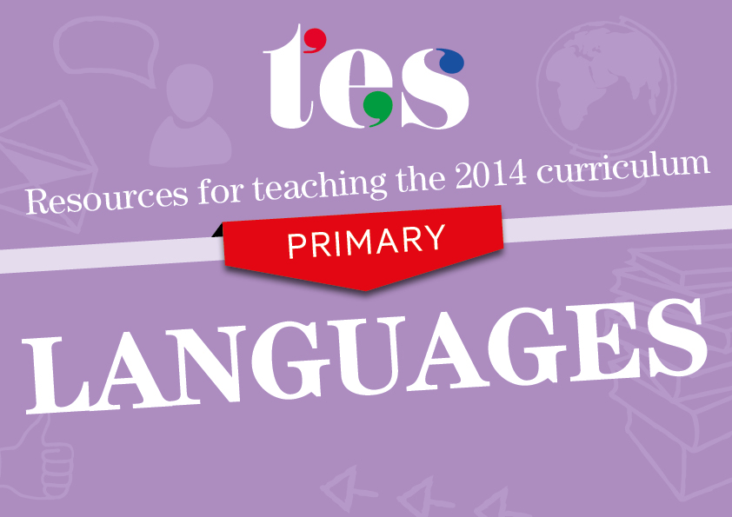
Spanish
Key Stage 2
Resources to help you teach the following curriculum areas for Spanish:

- Listening
- Speaking
- Reading
- Writing

Key Stage 2 Spanish – Listening

Pupils should be taught to:
- Listen attentively to spoken language and show understanding by joining in and responding | - Querido Zoo audio story  The Spanish version of Dear Zoo with embedded audio files.  - Body parts song  Learners show their understanding by joining in with the actions to this catchy song.  - Songs in Spanish  A number of finger rhymes and children’s songs in Spanish.  - El nabo gigante storytelling lesson  Learners join in with the repeated phrases, responding with actions to the story.
- Explore the patterns and sounds of language through songs and rhymes and link the spelling, sound and meaning of words | - Spanish vowel sounds rap  A rap to practice vowel sounds with p in Spanish.  - Spanish playground games  This resource includes a number of playground rhymes and songs in Spanish.  - La Casa de Pedro  A repetitive story that grows as learners listen and repeat.  - Practice of pronunciation of Spanish vowels audio  Learners listen and fill in the missing vowels by making links between sound and spelling.

Key Stage 2 Spanish – Speaking

Pupils should be taught to:
- Engage in conversations; ask and answer questions; express opinions and respond to those of others | - Jugo de naranja song  This song about orange juice introduces opinions in Spanish – me gusta / no me gusta.  - Spanish phonics  Learners are encouraged to make simple sentences giving their opinions, both positive and negative, of images.  - Expressing simple opinions about nouns  Learners express simple opinions about singular and plural nouns in Spanish.  - Easy learning conversation Spanish  Short audio clips with lots of everyday Spanish phrases.
- Seek clarification and help | - Spanish phonics  This resource includes important phrases to help learners seek help in the Spanish classroom.  - Using Spanish in the classroom  A game that encourages the use of Spanish in the classroom for daily routines.  - Toolkit phrases  Some important phrases for learners to use when seeking help, with audio.  - ¿Cómo se escribe?  Asking how to spell a word is a frequent and important question.
- Speak in sentences, using familiar vocabulary, phrases and basic language structures. Describe people, places, things and actions orally | - Spanish hobbies and sports  A presentation to enable learners to vocalise their likes and dislikes in sentences.  - Classroom items vocab practice  Learners watch items fly across the screen and state what they see in a sentence using es and the appropriate indefinite article (un/una) with the item.  - Donde vives y que hay allí  Learners form simple sentences about where they live.  - Sentence building  Learners use sentences about picture A to form sentences about picture B.
- Develop accurate pronunciation and intonation so that others understand when they are reading aloud or using familiar words and phrases | - Spanish phonics  A presentation that contains key Spanish phonics.  - Phonics – Trabalenguas  Tongue twisters to increase fluency and pupils’ ability to get their mouths around the sounds of Spanish.  - Spanish sounds – Phonic hooks  A presentation on the pronunciations c, g, h, j, ll, ñ, v and z in Spanish with accompanying video.  - Phonics card activity  Picture slides that can be printed out and made into a phonics card activity.
- Present ideas and information orally to a range of audiences | - ¿Qué tiempo hace?  Learners create weather reports in this activity.  - La cenicienta  Learners take part in a short play in Spanish.  - Pilar se presenta  Learners listen to Pilar introducing herself and prepare their own introduction.  - Expressing simple opinions  Learners express their opinions, both positive and negative, about various images and ideas.

Key Stage 2 Spanish – Reading

Pupils should be taught to:
- Read carefully and show understanding of words, phrases and simple writing | - Spanish phonics – Cognates  This resource encourages learners to look at cognates (English/Spanish) and pronounce them using Spanish phonic rules.  - Los deportes and las opinions  This resource includes a reading activity where learners match short statements about individuals’ sporting preferences to images.  - Me gusta plates  Learners read short texts about food likes/dislikes and draw food onto plates accordingly.  - A letter about musical opinions  A reading comprehension on a short letter about musical preferences.
- Appreciate stories, songs, poems and rhymes in the language | - La oruga hambrienta audio story  Spanish version of The Very Hungry Caterpillar with embedded sound files.  - Rhyme and song about months  A rhyme to remember the number of days in the months and a song linked to San Fermín celebrations that also feature months.  - Hombre de color presentation  A simple story in Spanish using colours and with a moral about racism.  - La Primavera by Antonio Machado  Learners read and respond to this Spanish poem about spring.
- Broaden their vocabulary and develop their ability to understand new words that are introduced into familiar written material, including through using a dictionary | - Los habitates – Animal habitats  Learners match animal pictures to their names in Spanish, then to their habitats.  - Numbers 1-31 in several languages  Learners complete a table of numbers 1-31 in Spanish, French and Latin by comparing languages and looking for patterns and clues.  - Usar un diccionario  A presentation with activities to help learners use a bilingual dictionary (first of a series of three).  - Dictionary skills  This resource familiarises learners with the layout of a bilingual dictionary.

Key Stage 2 Spanish – Writing

Pupils should be taught to:
- Write phrases from memory, and adapt these to create new sentences, to express ideas clearly | - Poema del monstruo  The poem starts and learners complete it to describe their monster by comparing his features to other things.  - Querido Zoo storyboard  Having listened to and repeated the story of Querido Zoo, learners adapt the story to create their own version using this storyboard as support.  - Nationalities  Learners work on a poem and then recycle vocabulary to create their own version.  - Mini-book project  Having worked on a story for several weeks, learners make a mini-book and write their own version
- Describe people, places, things and actions in writing | - Señor Cabeza Naranja  A simple story that provides a stimulus for learners to write their own versions of the story.  - Telling the time writing practice  Pupils write the time shown on the clocks in Spanish.  - Baboon on the moon  Learners write human sentences as a class, as well as forming individual texts about a silent film.  - Mi colegio  Learners reply to a letter and describe their school in Spanish.

Key Stage 2 Spanish – Grammar

Pupils should be taught to:
- Understand gender of nouns, definite and indefinite articles | - Comida y bebida categorizar  An activity in which learners sort food and drink vocabulary according to gender.  - Backpack vocabulary: Gender practice activity  Learners decide if items are masculine or feminine and see the items move to the correct side – red for feminine, blue for masculine.  - Happy families game  A card game to reinforce the idea of gender in Spanish.  - Masculine and feminine animals  Learners are introduced to gender in this resource and given a tip on deciding which gender a noun might be.
- Understand singular and plural forms of nouns | - Introduction of plurals of animals  A clear introduction to making plurals by adding an -s.  - Singular and plural articles  Learners look at the connection between gender and the definite and indefinite article.  - Nuestros amigos los animales  Learners apply rules they have learnt to predict the plural form from singular noun given, and learn new ones.  - Pencil case vocabulary odd one out  An odd-one-out resource with the ‘odd one out’ decided by number or gender.
- Recognise adjectives, place and agreement | - Introduction to the concept of adjectival agreements  This simple presentation clearly shows how adjectival agreement works in Spanish using animal and colour as the context.  - ¿Cómo eres?  An activity in which learners look for mistakes based on adjectival agreements.  - Adjectival practice with Mr Men and Little Miss  Children decide on the adjectival ending on the names of the Mr Men and Little Miss.  - Adjectives to give reasons  A gap-fill to practice adjectival agreements with opinions.
- Conjugate key verbs (and make verbs negative) | - Backpack vocabulary positive and negative responses  Learners form positive and negative responses using the verb ‘tener’.  - Spanish holidays presente  A presentation that presents the verb ‘ir’ using a song and then uses it to describe holidays.  - Present tense of ser and estar using the gerund  A video presentation on the use and conjugation of ser and estar  - Los medios de transporte  This activity focuses on transport vocabulary in Spanish.
- Use high-frequency sentence-builders, such as connectives and qualifiers, (adverbs of time, prepositions of place) | - Pedro y la caja story prepositions  Learners are introduced to prepositions of place through an illustrated story about Pedro the dog.  - Routine and adverbs 1 – Routine and adverbs 2  This pair of resources uses reading comprehensions to introduce adverbs ending with ‘mente’ in the context of routine.  - Connectives and opinions display  Attractive display with connectives on Spanish plugs.  - Como/bebo + frequency phrases  An activity to form sentences about how often food/drink is eaten/drunk using frequency phrases and connectives.

