 | Multimedia and Word processing | Digital media | Programming  2 forms/languages | Communication and Collaboration | Data | E-Safety
Year 4 | - Evaluate a range of electronic multimedia, appropriate to task e.g website, photostory, leaflet, and recognise key features of layout and design  - With support, plan structure and layout of document/ presentation  - Select and import graphics from digital cameras, graphics packages and other sources and prepare it for processing using ICT  - If project is multimedia, select and import sounds (eg own recording, sound effects bank created by teacher) and video/ visual effects  - Through peer assessment and self evaluation, evaluate work both during and after completion, and make suitable improvements  - Develop increasing sense of audience  When word processing children should:  - choose freely from a range of text styles, to suit audience  - hold two hands over different halves of the keyboard  use more than two fingers to enter text | Graphics  - import a photograph and explore the effects which can be created  - use a range of visual effects such as filters, hues and painting over photographs.  - Create patterns and montages  - select areas and manipulate to give different effects.  Music and Sound  - listen to a variety of radio programmes, evaluating their style  - write a script for a radio programme  - plan and record audio for a radio program, eg interview, news broadcast, advert, cookery programme  - evaluate and re-record (maybe editing)  - maybe publish work online as a podcast | Programming Unit 1: Scratch Simple Game  - Navigate the Scratch programming environment.  - Create a background and sprite for a game.  - Add inputs to control their sprite.  - Use conditional statements (if… then) within their game.  Programming Unit 2: Kodu  - Navigate the Kodu macro environment using keyboard and mouse  - Create a 3D digital world for a game with land, water and scenery.  - Add a sprite to their world.  - Program their sprite to navigate their 3D world with an input.  - Create paths on which sprites will move.  - Use conditional statements (‘if…then’) to give objects behaviours | - select from your best work to save and share through an e-portfolio  - use at least two online communication methods (eg online discussion, surveys, quizzes, blogs, wikis, shared online folders, web quests) through the Learning Platform in topic work  - discuss advantages and disadvantages of these communication methods  - To start to think about the different styles of language layout and format of online communications sent to different people (eg. when it is appropriate to use “text language”). | Graphing  - Have regular opportunities to enter data into a graphing package and use it to create a range of graphs, and to interpret data across all subjects  - To compare how different graphs can be used for different purposes  Branching Databases  - search a branching database  - create and use a branching database to organise, reorganise and analyse information  - compare the use of graphing software, branching database and card-based database for organising and interpreting data  - explore some real-life examples of branching databases, such as keys for animal indentification | E-Safety Online Research  Use internet search engines to gather resources for their own research work.  Be aware of different search engines and discuss their various features (e.g. Google image & video search).  Show children how to change the ‘Search Settings’ to Strict in Google.  Understand the importance of framing questions into search criteria when conducting web searches.  Be aware that not everything they find online is accurate and that information needs to be checked and evaluated.  E-Safety Communication & Collaboration  Children use online communication tools to exchange and develop their ideas in a range of curriculum opportunities.  Use sensitive and appropriate language when using online communication tools.  Use email as a form of communication, use the “To” box and add a subject heading.  Add an attachment to an email.  Develop understanding of when it is unsafe to open an email or an email attachment.  E-Safety E-Awareness  Children understand and abide by the school’s ‘Being SMART Online’ rules and aware of the implications of not following the rules.  Children understand that a password can keep information secure and the need to keep it a secret.

Unit/Project | Statutory requirements/ key skills | Notes | Possible outcomes and activities
Multimedia and word processing  Comp KS2 6 (7) | - Evaluate a range of electronic multimedia, appropriate to task e.g website, photostory, leaflet, and recognise key features of layout and design  - With support, plan structure and layout of document/ presentation  - Select and import graphics from digital cameras, graphics packages and other sources and prepare it for processing using ICT  - If project is multimedia, select and import sounds (eg own recording, sound effects bank created by teacher) and video/ visual effects  - Through peer assessment and self evaluation, evaluate work both during and after completion, and make suitable improvements  - Develop increasing sense of audience  When word processing children should:  - choose freely from a range of text styles, to suit audience  - hold two hands over different halves of the keyboard  use more than two fingers to enter text | Suggested Resources  Multimedia Authoring packages: Powerpoint – Create slides and add pictures, text, WordArt, Video  Word processing packages: Word – Word processor  Photostory 3 (as whole class) - combines photos into a slideshow and allows sound, voice commentary and titles to be added.  Touch Typing Course – Links on Fronter which included BBC Dance Mat Typing (www.bbc.co.uk/schools/typing)  Primary Pad – Web-based word processor designed for schools that which allows pupils to work together in real-time | Plan, design and create and improve their own multimedia presentation showing awareness of audience.  Literacy – type a literacy story or newspaper report and send it to a friend / someone in another school for them to review.  Science/Topic – Create a presentation about a topic area.  PSHE – Create a PhotoStory presentation that addresses Bullying and strategies to deal with it.  Year 4 to revise Touch Typing course during Book Browse and find opportunities to apply. (See Fronter room)
Music and Sound  Comp KS2 6 (7) | - listen to a variety of radio programmes, evaluating their style  - write a script for a radio programme  - plan and record audio for a radio program, eg interview, news broadcast, advert, cookery programme  - evaluate and re-record (maybe editing)  - maybe publish work online as a podcast | Suggested Resources  EasiSpeak Microphone - Simple microphones which allow recording of sounds  2 Simple Music Toolkit - A range of music related programs for adding sounds, creating phrases etc...  Podium – Simple sound editing program in which sound clips can be added  Audactiy – Sound editing program with more features than Podium. Also allows multiple layers of sound  Online sources of sounds: www.findsounds.com; Audio Network http://audio.lgfl.org.uk ; Microsoft ClipArt Online | Plan and record material for a radio programme  Topic – Report on events during Boudicca’s revolt. Post work onto Fronter  Literacy – Create a question and answer podcast in role (e.g. interview and animal about their habitat) and layer sound effects to the background.
Graphics  Comp KS2 6 (7) | - import a photograph and explore the effects which can be created  - use a range of visual effects such as filters, hues and painting over photographs.  - Create patterns and montages  - select areas and manipulate to give different effects. | Suggested Resources  Paint.net – Picture editing program with a range of onscreen tools for different affects | Create digital artwork by photograph editing.  Robots – create a picture of a robot using metallic colours.  Literacy – Create a scene to use as a setting for a story  Topic – Create a piece of art in the style that is tradition with your focus country.
Programming Unit 1: Scratch : My first game  Comp KS2 1,2,3 (7) | - Navigate the Scratch programming environment.  - Create a background and sprite for a game.  - Add inputs to control their sprite.  - Use conditional statements (if… then) within their game. | Scratch activity cards and tutorials at http://scratch.mit.edu/help/  Blog by Simon Haughton with lots of ideas and lesson plans http://www.simonhaughton.co.uk/scratch-programming/ | Create a simple game where if a conditional statement is met then they start again or lose e.g. don’t touch the edge of a maze.
Programming Unit 2: Kodu  Comp KS2 1,2,3 (7) | - Navigate the Kodu macro environment using keyboard and mouse  - Create a 3D digital world for a game with land, water and scenery.  - Add a sprite to their world.  - Program their sprite to navigate their 3D world with an input.  - Create paths on which sprites will move.  - Use conditional statements (‘if…then’) to give objects behaviours | Use Kodu guidance on meeting these objectives.  http://csamarktng.vo.msecnd.net/kodu/pdf/kodu_curriculum_keyboard_mouse.pdf or type in http://tinyurl.com/q65qtoo | Topic  Create a world to settle in. What resources would be needed e.g. rivers, mountains, trees. Create the world and navigate a sprite around it.
Communication and Collaboration  Comp KS2 4, 6 (7) | - select from your best work to save and share through an e-portfolio  - use at least two online communication methods (eg online discussion, surveys, quizzes, blogs, wikis, shared online folders, web quests) through the Learning Platform in topic work  - discuss advantages and disadvantages of these communication methods  - To start to think about the different styles of language layout and format of online communications sent to different people (eg. when it is appropriate to use “text language”). | Suggested Resources  E-Safety Room on Fronter - A range of links, information, games and videos about e-Safety  Email – Class email  VLE –School’s online classroom where children’s work can be uploaded. Also has chat, vote, quiz and forum functions | Use at least two online communication methods through the Learning Platform. Understand the SMART internet safety rules.  Topic – Create topic page on Fronter with at least two forms of online communication and then share with other classes to investigate and comment on.  Maths – Use Stickies to find answers for data handling question  Link to e-Safety  Children use a range of communication tools to collaborate and exchange information with others, e.g. email, blog, forums.
Handling Data  Comp KS2 6 (7) | Graphing  - Have regular opportunities to enter data into a graphing package and use it to create a range of graphs, and to interpret data across all subjects  - To compare how different graphs can be used for different purposes  Branching Databases  - search a branching database  - create and use a branching database to organise, reorganise and analyse information  - compare the use of graphing software, branching database and card-based database for organising and interpreting data  - explore some real-life examples of branching databases, such as keys for animal identification | Suggested Resources  Excel- Create graphs and spreadsheets  Textease Branch – Create branching databases | Collect, find, organise and interpret information using graphing and a branching database.  Maths – use data collected in maths to create graphs and charts.  Science – Create database to solve sorting problems in Science e.g. sort what material a mystery sample is.

Unit/Project | Statutory requirements/ key skills | Notes | Possible outcomes and activities
E-Safety  Online Research  Comp KS2 7 | - Use internet search engines to gather resources for their own research work.  - Be aware of different search engines and discuss their various features (e.g. Google image & video search).  - Show children how to change the ‘Search Settings’ to Strict in Google.  - Understand the importance of framing questions into search criteria when conducting web searches.  - Be aware that not everything they find online is accurate and that information needs to be checked and evaluated. | Use the e-SAFE Fronter page (Safe Searching page for other tips)  Children’s search engines;  www.kidsclick.org  http://kids.yahoo.com/  www.askforkids.com  ThinkUKnow Cybercafe Lesson 5, `Responsible use of the internet’  www.thinkuknow.co.uk/8_10/ (click on Jason for the web browsing section)  KnowITall Activity 2 (The SMART Adventure); complete the website treasure hunt  CyberQuoll Episode 2 – ‘Finding Stuff’ (safe searching) and lessons 2.1-2.5 http://www.cyberquoll.com.au  Spoof website www.allaboutexplorers.com  SMART Rule - Reliable | This could be taught as a separate Life Skills lesson or as part of another ICT lesson.  Refer to the E-SMART rules.
E-Safety Communication & Collaboration  Comp KS2 7 | - Children use online communication tools to exchange and develop their ideas in a range of curriculum opportunities.  - Use sensitive and appropriate language when using online communication tools.  - Use email as a form of communication, use the “To” box and add a subject heading.  - Add an attachment to an email.  - Develop understanding of when it is unsafe to open an email or an email attachment. | CyberQuoll Episode 3 – ‘Making Waves’ (cyber communication) and lessons 3.1-3.7 http://www.cyberquoll.com.au  ThinkUKnow Cybercafe lesson 1, “Using technology to communicate” & lesson 4, “Using email safely”  SMART Rules - Messages | This could be taught as a separate Life Skills lesson or as part of another ICT lesson.  Refer to the E-SMART rules.
E-Safety E-Awareness  Comp KS2 7 | - Children understand and abide by the school’s ‘Being SMART Online’ rules and aware of the implications of not following the rules.  - Children understand that a password can keep information secure and the need to keep it a secret. | School Internet Acceptable Use Policy  KS1 and 2 Safer Internet Day Assembly video http://www.thinkuknow.co.uk/teachers/  Top Tips for Safe Surfing poster from LGFL  KS2 Internet Safety poster from KGFL  KnowIT All Activity 3 (The SMART Adventure); drama activity highlighting an e-Safety issue.  “Where’s Klaus” video from CEOPS (teachers will need to register at the ThinkUKnow website in order to download this video).  SMART Rules - Safe | This could be taught as a separate Life Skills lesson or as part of another ICT lesson.  Refer to the E-SMART rules.

Scratch

Section A (2/3 lessons) Pupils will work through with the teacher to construct a model game which incorporates the programming skills/features for the year group - thus giving the teacher time to explicitly teach these skills. The model game for this is provided below.

Section B: Coding Challenge: (2/3 lessons) Pupils will work individually, in pairs or in groups to design their own adaptation of the modelled game in section A; thus giving pupils the opportunity to apply the skills taught in this unit.

As such, what follows are details of the model game which pupils will work through together with the teacher. This is followed by guidance for ‘Section B’ of the program of lessons, when pupils may make adaptations of the game. Such guidance suggests ways in which pupils may adapt, extend or completely redesign the game.

Section A: Example to create a Racing car game (2/3 lessons)

Please note the following Racing Car game resources come from Simon Haughton (@simonhaughton) who kindly agreed they could be reproduced here.

The Year 4 model game is a simple racing car game in which pupils create a racing track background and add a racing car sprite. They then program the sprite so it is controllable. ‘If……then’ programming is also used so if the car touches the grass then it returns to the beginning and a winning message is displayed when it reaches the end.

Note – this game uses the inbuilt picture editor to create the background. This can be accessed by clicking the ‘stage’ icon towards the bottom right then clicking ‘background’ and ‘paint’. Shown in the screen shot below. The features within this paint program are very similar to other graphics packages that pupils will have experience of using e.g. brush tool, eraser, fill tool.

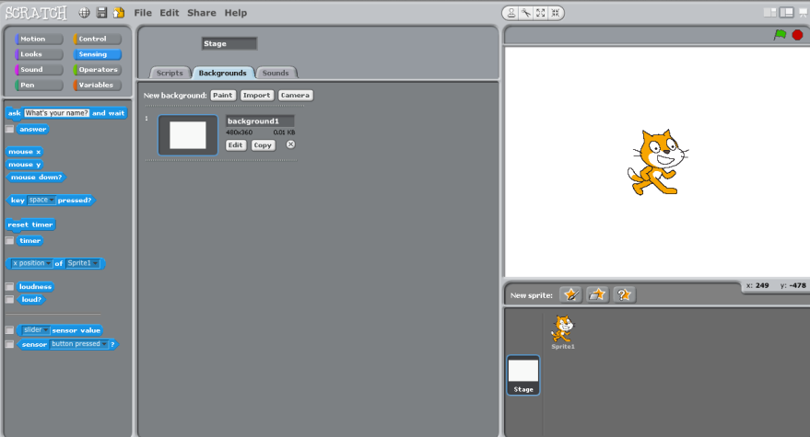
Click stage

Click background

Click paint

Please follow the steps below with your class to construct the model game for this unit. It is envisaged that each step will be modelled on the computer at the front of the Media Suite before pupils attempt it themselves. It may also be worth printing out these instructions for pupils, as well as displaying them on the IWB. Also, remind pupils to save there work regularly!

The Year 4 skills to emphasis as you are working through the programming of this model game are:

- Navigate the Scratch programming environment.
- Create a background and sprite for a game.
- Add inputs to control their sprite.
- Use conditional statements (if… then) within their game.

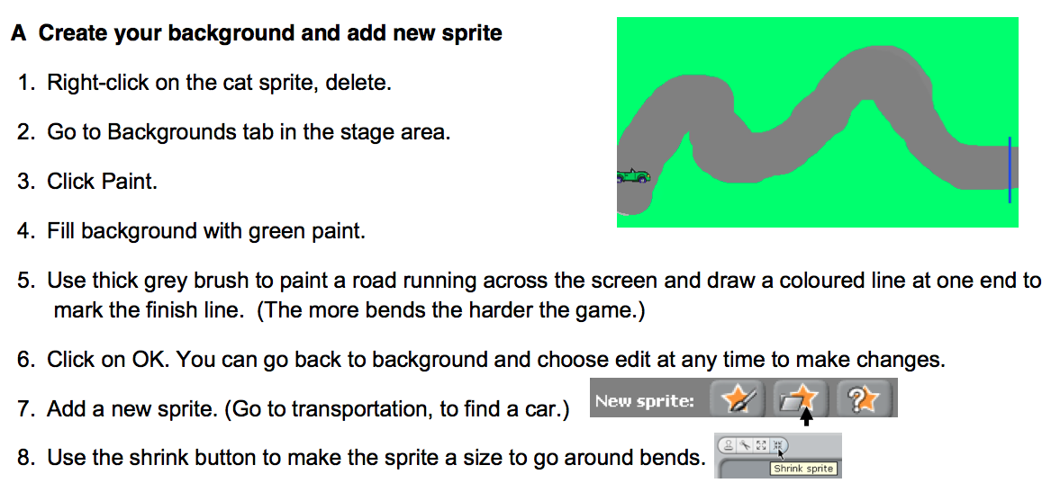
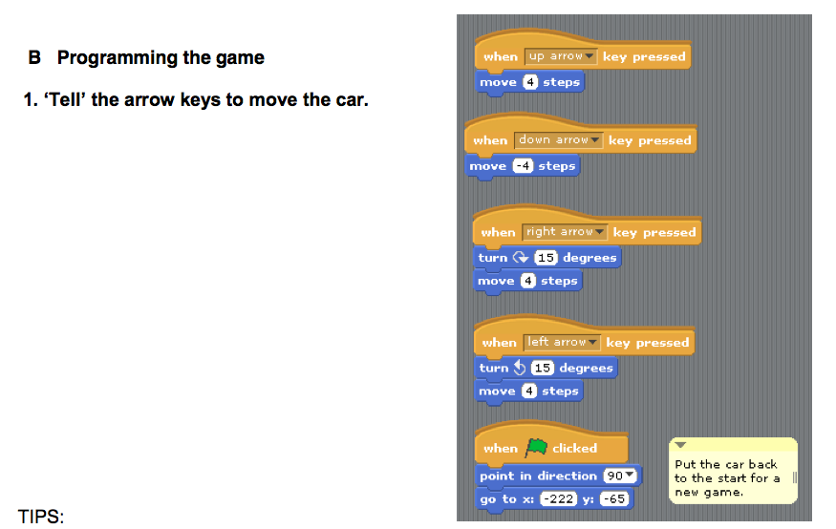
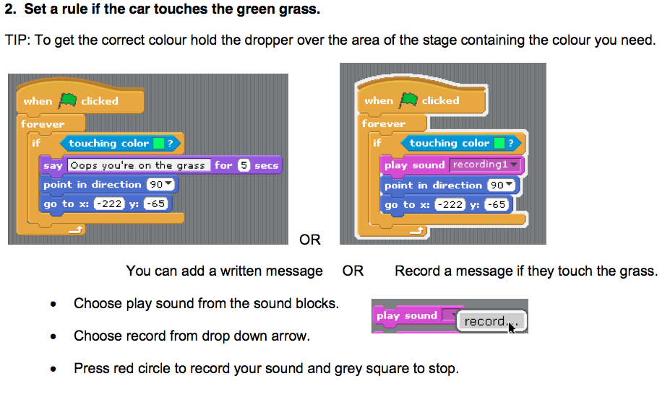
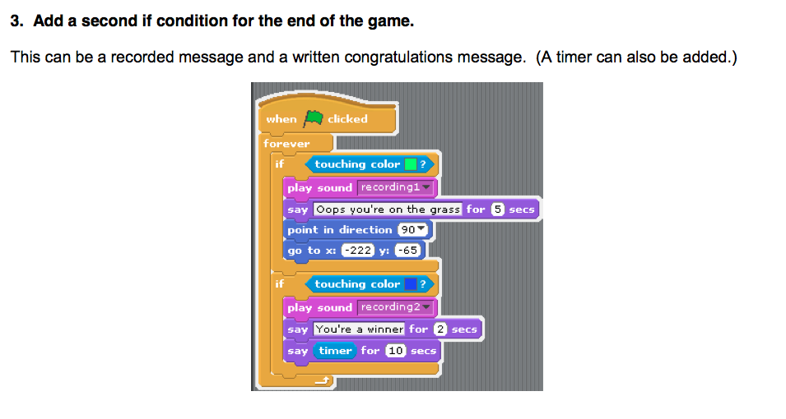
Once you have worked through the steps above to program the model game please give time to pupils to play each other’s games and display a range of examples on the IWB at the front of the Media Suite – by the pupils saving the game and it being opened on the iMac at the front of the Media Suite. All the games will be slightly different as pupils had to draw their own backgrounds and this will influence how easy or difficult the game is to play. Please question the pupils about the differences between the games and how this influences playability.

Coding Challenge: Pupils designing their own games (2/3 lessons)

Following the construction of the model game as a class, it is not envisaged that all Year 4 pupils will design entirely new games, rather that pupils will, to a varying degree, alter the model game above. Pupils may, for example, change the appearance of the game so it features a different sprite and different background – a cat running around a bridge on water for example. Here the coding from the model game can be adapted for their own game. More able pupils may extend the game to include dangerous items in the background – using if then conditional blocks, touching the colour of these items could cause the sprite to vanish or ‘say Help!’ for example.

When adapting/designing their games, it is envisaged pupils may sketch out on paper their new designs first, engaging in a design process and talking through their designs using the language associated with programming (they could present their designs to the class) i.e. this sprite will be controlled by the keys…. etc. In a similar manner they should learn to articulate the conditional statements used within the game i.e. If it touches… then it will say…. etc. By designing their game on paper first, then the coding that follows is ‘for a purpose’, in that they have a desired outcome in mind as opposed to freely generating code to see what the outcome may be.

Once pupils have finished programing their games, a lesson themed as a games fair could be held in which each of the iMacs are running the pupils games and pupils are free to play, comment on and evaluate their own games and the games of others. Time could then also be spent discussing with the pupils what changes they would make and why if they were to reprogram their games - and if time permits pupils should be given the chance to make these improvements.

