CHRISTMAS FRACTIONS

1. How many baubles are on the tree?

2. Harry’s Mum wanted ¹/₁₅ of the baubles to be yellow. How many are yellow?

3. If ¹/₅ of the baubles are red, how many baubles are not red?

4. Harry’s hamster knocked ¹/₃ of the baubles off the tree. How many baubles were left on the tree?

5. ¼ of the presents underneath the tree are for Rebecca. If there are 20 presents underneath the tree, how many will Rebecca get?

6. What fraction of the presents are not for Rebecca?

7. Santa took ²/₅ of Rebecca’s presents away because she was too naughty. How many did she have left?

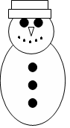
8. ½ of all the carrots in the supermarket were bought to make snowman noses. If the supermarket sold 168 carrots, how many ended up as noses?

9. Emily used 5 pieces of coal for the buttons, 7 pieces of coal for the mouth and 2 for the eyes. What fraction of the coal did she use to make the mouth?

10. The scarf is ³/₈s red and ⁵/₈s yellow. If there are 16 sections on the scarf, how many are red?

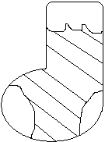
11. Draw a Christmas stocking in your maths book. Decorate your stocking with 24 stars or circles. Colour:

¼ yellow
¹/₃ red
^{3/}₁₂ green
¹/₆ blue

